Multibeam survey of kelp beds – Pilot study log
Crew: Sean Blake (dive/boat), Mahala Ebery (dive), Alexandre Schimel (multibeam survey), Adam Pope (dive attendant/boat)
Date: Thursday 13th February 2014.

Preparations
- 07:00 Meet at boat ramp
- Launched vessel
- Found suitable Macrocystis bed (~9m, intended: 10m). Location?
- 07:39 Anchored vessel in the bed
- Lowered a weighted shot line off each side of the boat

Harvesting
- 08:25 Start of Dive #1
- Each diver went down one of the shot lines carrying the weight/clip end of a dive reel. Boat crew kept the handle end of the dive reels and attach that end to the boat to avoid losing them.
- Each diver found the plants they wanted to harvest and tied the dive reel line close to the holdfast then cut holdfast from the substrate. Gave 3 strong tugs on the dive line to indicate the boat crew to haul the plants to the surface.
- Once boat crew had the holdfasts they sent the weight/clip end of the dive reel back down. They then used short length of rope to tie the holdfast to one of the bow rails, planning to end up with 8 plants on each side of boat (total 16 plants). We ended up with only 4 or 5 on the bow rails before it got too many and plants started getting entangled. Remaining plants were put in bags. Maybe for next time put the first 8 in bags and attach the last 8 to the boat to minimize entanglements.
- 09:25 End of Dive #1 (total: 1h, max depth 10.1m)
- Plants attached on the bow rail were then put in a bag
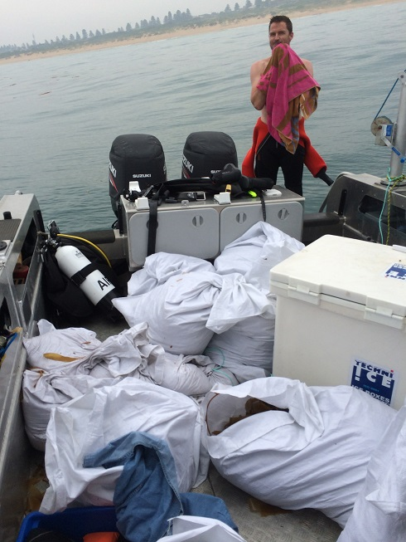

Measurements
- Back to breakwater to measure and weight each plant.
- Alex left.
- Laid one plant on ground. Measured from tip of fronds to start of branches (i.e. not including holdfast). Took photo of the plant.
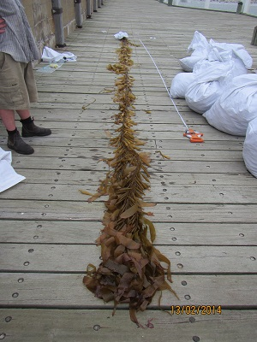
- Each plant was then labelled with a cattle tag and a regular bin bag was cable-tied around the holdfast to secure fauna in the holdfast.
- Took photo of the tag.
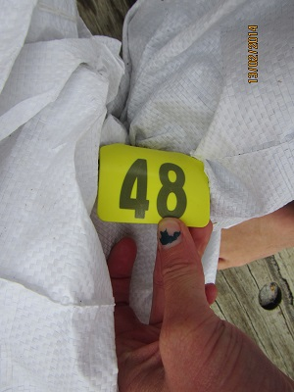
- Plant was then put back into its large white bag and weighted on a scale.
- To be able to read the scale, the bag was put in a fish bin on two wooden planks. Total tare to be removed from the measured weight: 2kgs.
 | Plant ID | Length (m) | Measured Weight (kgs) | Weight without tare | Photo?
1 | 48 | 8.2 | 12.4 | 10.4 | Y
2 | 33 | 9.8 | 23.6 | 21.6 | Y
3 | 45 | 7.6 | 22.9 | 20.9 | Y
4 | 47 | 11.0 | 24.6 | 22.6 | Y
5 | 49 | 11.3 | 15.8 | 13.8 | Y
6 | 50 | 10.35 | 24.1 | 22.1 | Y
7 | 46 | 9.6 | 19.1 | 17.1 | Y
8 | 56 | 9.4 | 16.5 | 14.5 | Y
9 | 57 | 10.4 | 25.2 | 23.2 | Y
10 | 55 | 10.4 | 11.2 | 9.2 | Y
11 | 58 | 7.55 | 12.0 | 10.0 | Y
12 | 62 | 9.1 | 13.3 | 11.3 | Y
13 | 63 | 10.9 | 10.9 | 8.9 | Y
14 | 61 | 10.4 | 21.0 | 19.0 | Y
15 | 54 | 9.4 | 19.7 | 17.7 | Y
16 | 64 | 9.6 | 14.3 | 12.3 | y

- 11:50 Finished weighing at breakwater.

Setting up dense forest patch
- Back on the water
- Identified a suitable sand site in 10m depth. Intended location for experiment: -38.40, 142.483. Actual location to be figures from the data.
- Dropped a shotline to the water
- Sand bags were attached near the holdfast of each plant, filled with 5 to 10 kilos of sand. Plants were then dropped overboard near the shot line and weighted holdfast dropped to the seabed. We tried to drop all plants on one side of the shot so that other side was available to setup the quadrat.
- The weight for each plant was enough but the surge made the bags drag on the floor. Two plants went missing by the time the divers went down (50 and 57 apparently).
- For next time, go in better swell conditions, and forget the sand bags and use sand screws to attach the plants to the bottom.
- 13:38 Start of dive #2
- Once all plants were in the water divers went down the shot line and set up the 4x4 quadrat (ropes and stakes).
- First stake was hammered in to constitute reference point.
- From the reference point, divers went straight North (0deg) to establish the West side of the quadrant then turned due East (90deg) to establish the North side of the quadrant. On the square below, the reference point is the bottom left corner (plant ID #61) so that North is upwards.
- Divers then moved each plant randomly into a cell in the grid (one plant per cell) and wrote down on a slate where each plant went.
46 | 56 | 64 | 63
 | 62 | 54 | 58
 | 49 | 33 | 48
61 | 55 | 47 | 45

- Once all plants were setup in the grid, divers went outside of quadrat and mark the 4 corners of the plot with small buoys attached to fishing lines. Small lines were used so that they don’t show on Multibeam data. Line were kept tight to keep buoys to the vertical of the corners.
- Underwater photos of the setup were taken
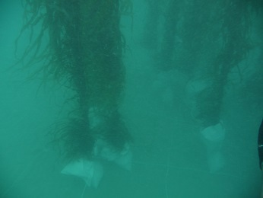
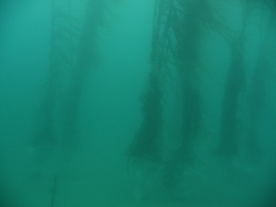
- Divers exited up shot line
- 14:35 End of dive #2
- Shot line was removed from the water. Alex and Sound Velocity Profiler (SVP) were picked up at port.
- 15:32 Start setting up for Multibeam survey.

First mutibeam survey
- SVP cast
- 16:28 first line acquisition
- 17:27 last line acquisition

Setting up thin forest patch
- 17:38 start of Dive #3
- Divers went back in. No shot line on that dive.
- Divers removed 7 plants from the quadrat (the plants having been removed were highlighted on the slate). Divers emptied the sand bags for these plants and let plants reach the surface. Plants removed were # 62, 54, 64, 46, 49, 48 and 45, so that only 56, 63, 58, 33, 61, 55, 47 remained. Leading to the following setup
 | 56 |  | 63
 |  |  | 58
 |  | 33
61 | 55 | 47

- Divers took more photos
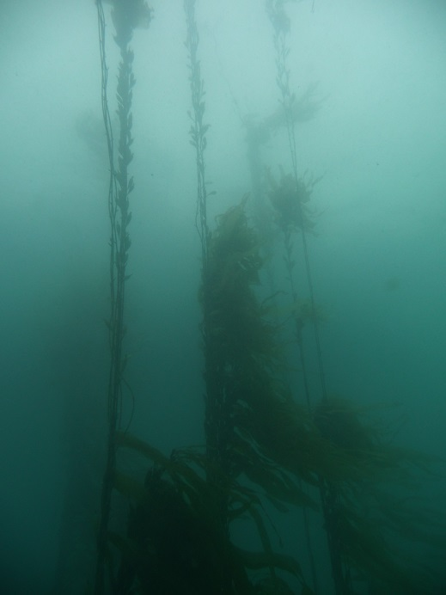
- Divers came back to surface
- 17:54 End of dive #3
- Boat crew and divers removed plants hauled to the surface and put in the large white bags.

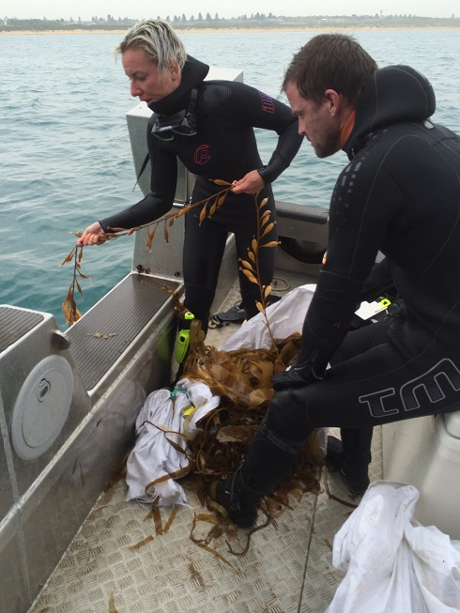

Second multibeam survey
- 18:13 – 19:12 Run second multibeam survey. At the same time holdfast for the plants removed were cut and put in ice.
- 19:28 Stopped POS logging.

Experimental site take-down
- 19:20 Start of Dive #4
- Shot line dropped again, divers went down.
- Divers emptied sand bags and prepared plants for retrieval with the same method used for thinning.
- Quadrat removed and gear was collected. Non buoyant objects were attached to the shot line to be hauled back later.
- Divers returned to surface.
- 19:40 End of dive #4
- Boat crew and divers collected gear and plants at surface and hauled back the shot line.
- 20:14: second SVP.
- Holdfasts for the remaining plants were cut off and placed in esky with ice.
- Back to port

