A comprehensive and updated compilation of the seismic stratigraphy markers in the Western Mediterranean Sea

Bellucci Massimo^{1,2,3}, Pellen Romain², Leroux Estelle¹, Bache François⁴, Garcia Marga⁵, Do Couto Damien⁶, Raad Fadl⁷, Rabineau Marina², Gorini Christian⁶, Moulin Maryline¹, Maillard Agnès⁸, Lofi Johanna⁷, Del Ben Anna³, Camerlenghi Angelo⁹, Poort Jeffrey⁶, Aslanian Daniel¹

1 IFREMER, Géosciences Marines, Plouzané, France
2 Univ. Brest, Laboratoire Géosciences Océan, UMR 6538 IUEM - CNRS, Plouzané, France
3 Dipartimento di Matematica e Geoscienze, Università di Trieste, Italy
4 GNS Science, PO Box 30-368, Lower Hutt, New Zealand
5 Univ. Barcelona, now at IEO, Cadiz, Spain
6 Sorbonne Université, CNRS, Institut des Sciences de la Terre de Paris, ISTeP, Paris, France
7 Géosciences Montpellier, CNRS, Université de Montpellier, Université des Antilles – Bâtiment 22, Université de Montpellier 2, Place E. Bataillon, Montpellier Cedex 05,34095, France
8 Géosciences Environnement Toulouse (GET), Observatoire Midi Pyrénées, Université de Toulouse, CNRS, IRD, 14 avenue E. Belin, Toulouse, F-31400, France
9 Istituto Nazionale di Oceanografia e di Geofisica Sperimentale OGS, Trieste, Italy

Abstract
The Western Mediterranean Sea is a natural laboratory to address questions about the formation and evolution of continental margins and the relationship between surface and deep processes. The evaporites deposited during the late Miocene’s Messinian Salinity Crisis (MSC) strongly impact its sedimentological and geomorphological evolution. Hereafter, we present a compilation of some of the main regional seismic stratigraphic markers throughout all the Western Mediterranean Sea. We provide in xyz format (z in second twt) the original, not interpolated, points interpretation of the following horizons: i) Acoustic basement, ii) Base and Top of the MSC salt, also known as Mobile Unit (MU), iii) base Pliocene and iv) Seafloor. The available reflection seismic dataset, coming from a collaboration between French, Spanish, Algerian and Italian research institutes, covers most of the Western Mediterranean sub-basins with the exception of the Ligurian Basin. This compilation is currently the most comprehensive and updated available in literature and provides a useful contribution to the scientific community working in sedimentary, tectonics and geodynamics studies in Western Mediterranean Sea.
Brief dataset history
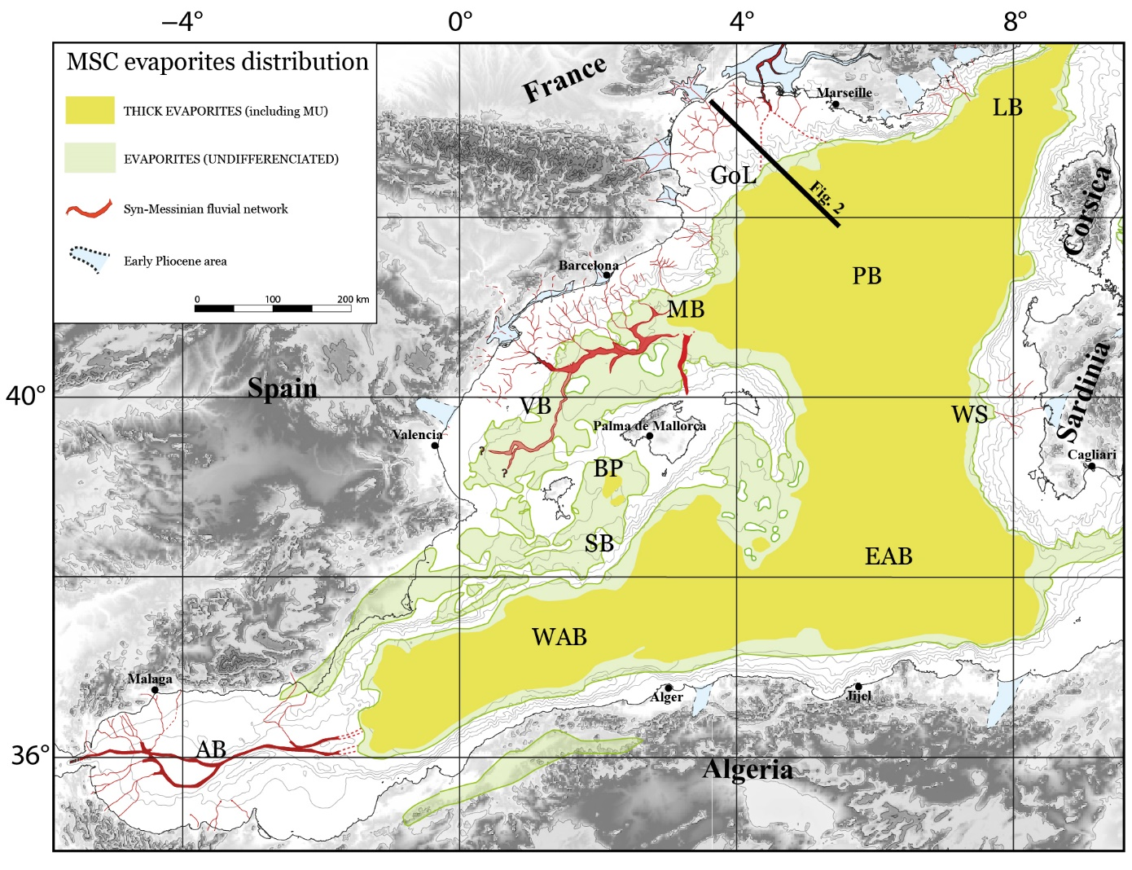
Since the 1960s the Western Mediterranean Sea has been exploited by reflection seismic surveys, both with academic and industrial objectives. Although some surveys are relatively old, new processing techniques have allowed a good improvement of quality. The results gave a great variability of available data, with strong differences in resolution and quality. In the Western Mediterranean area (Fig. 1), a first industrial and academic reflection seismic compilation was made by Mauffret, (1976), Gorini, (1993) and Maillard, (1993), complemented by Bache, (2008), Garcia et al., (2011), Leroux, (2012), Driussi, (2014) and Pellen, (2016). The last three aforementioned authors digitalized a dense seismic grid in the Valencia and Menorca basins as well as the Balearic Promontory. Over the years the dataset has grown, thanks to collaborations between several French and foreign institutes and industry, such as the GDR “Margins” (Groupement de Recherches 'Marges') followed by Action Marges, which had the objectives to better understand the processes that control the formation and evolution of continental margins (e.g. Berne & Gorini, 2005).
Figure 1. Extension map of the MSC evaporites in the Western Mediterranean Sea (modified after Rabineau et al., 2015 and Pellen et al., 2019). LB: Ligurian basin; GoL: Gulf of Lion margin; PB: Provençal basin; WS: western Sardinian margin; EAB: eastern Algerian basin; WAB: western Algerian basin; AB: Alboran basin; SB: south Balearic margin; BP: Balearic Promontory; VB: Valencia basin; MB: Menorca basin. Black line indicates the approximate position of the profile showed in figure 2.

Within this framework, we could undertake multidisciplinary studies through a collaboration between the University of Brest, Ifremer, Sorbonne University, University of Montpellier, University of Toulouse, University of Barcelona, Consejo Superior de Investigaciones Cientificas (CSIC), TOTAL, IFP Energies Nouvelles and Bureau de Recherches Gélogiques et Minières (BRGM).
More recently, we added some new lines to the dataset coming from the Italian institutions thanks to the close collaboration with OGS (National Institute of Oceanography and Applied Geophysics) and the University of Trieste. To this date, this work provides the largest and most comprehensive stratigraphic markers compilation available to the scientific community across the Mediterranean Sea.

Stratigraphic markers presentation
This work provides the interpretation of several stratigraphic markers, below briefly described and referred (Fig. 2). We provide xyz files, where x is the longitude, y the latitude and z the depth in second twt. The coordinates are not projected and the datum/ellipsoid is the WGS84 (EPSG 4326).
Figure 2. A) Synthesis of offshore stratigraphic markers on a profile crossing the Gulf of Lion margin (location figure 1). PQ: Plio-Quaternary sequence; MSC: Messinian Salinity Crisis. LU: Lower Unit; MU: Mobile Unit; UU: Upper Unit;MES: Margin Erosion Surface; TES/TS: Top (Erosion) Surface; BES/BS: Bottom (Erosion) Surface; CU: Complex Unit. MLM: Messinian Lower Megasequence; MUM: Messinian Upper Megasequence; LU0: erosion on the shelf and detrital deposits in the basin. The base of the PQ sequence corresponds to the MES on the shelf, to the top of MSC detrital units on the slope and to the top of UU in the basin (modified after Leroux et al., 2019). B) Seismic zoom representing seismic units facies and reflectors provided in this work.
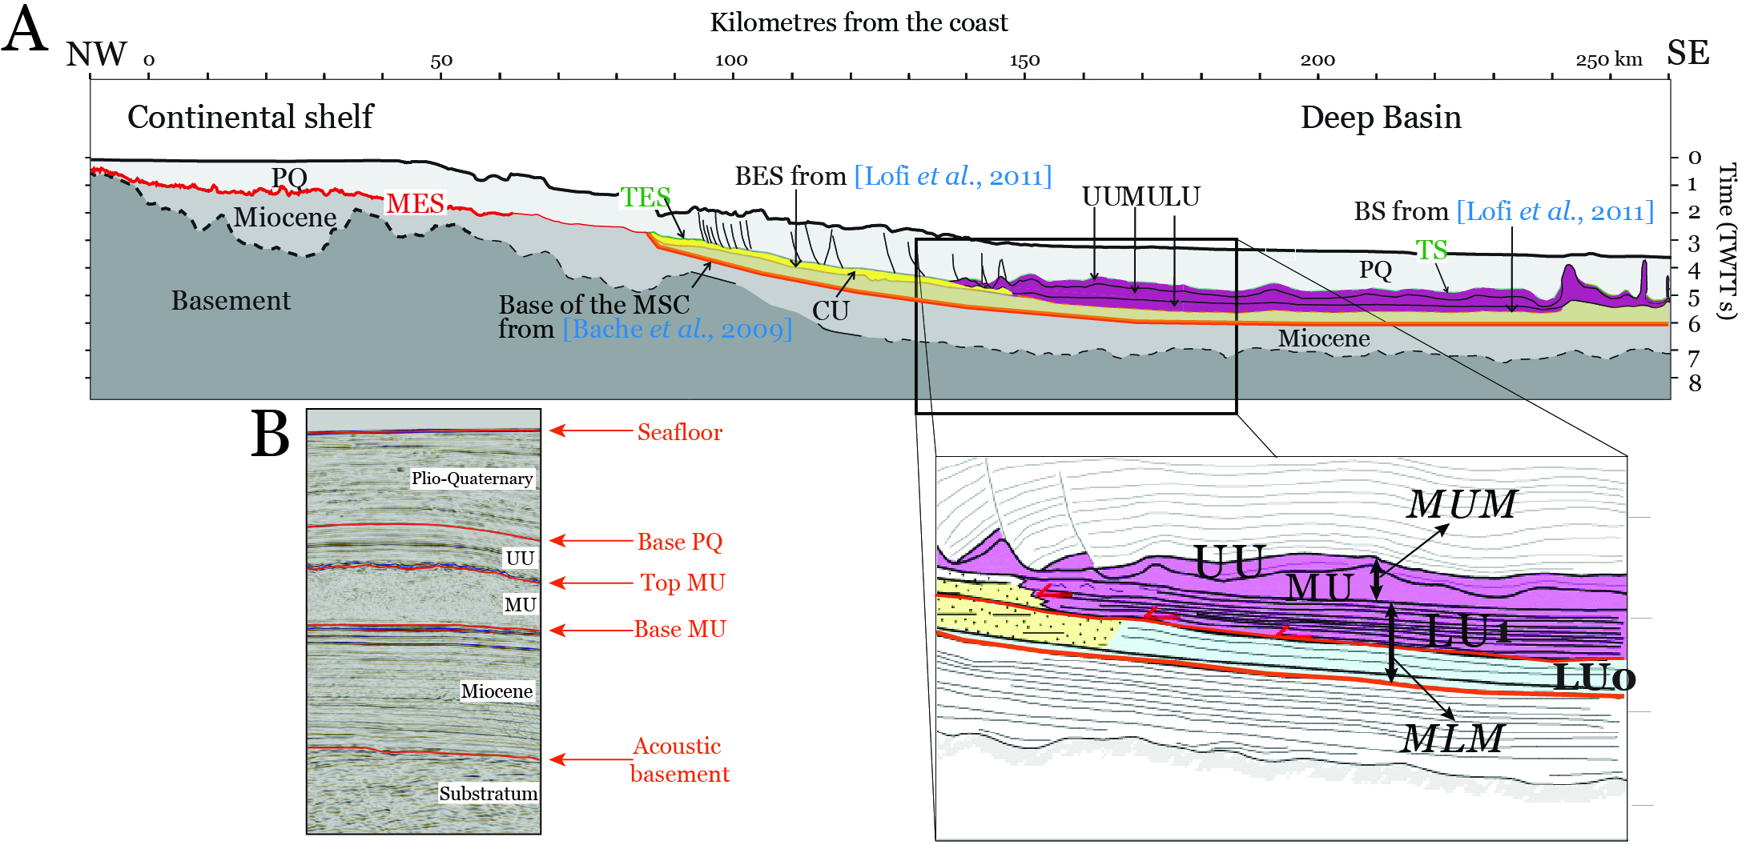
The Top acoustic Basement is interpreted in all the geomorphological domains, from the shelf to the deep basin (Fig. 3). It coincides with the deepest continuous, high amplitude and positive polarity (SEG normal polarity) reflector in the sedimentary column. It separates the chaotic seismic facies of the substratum from the stratified seismic facies of the sedimentary column (Fig. 2). In the Alboran and Valencia basins it corresponds to the Base of the Tertiary, or Oligocene unconformity (e.g. Do Couto et al., 2014; Pellen et al., 2016; Etheve et al., 2016).
The Base of salt marker is interpreted only in the deep basin, where the MSC Salt is observed (Fig. 4). It corresponds to the base MU (Mobile Unit), from Lofi et al., (2011) and base MUM (Messinian upper megasequence) in the deep basin, from Gorini et al., (2015). The MU is absent elsewhere in our study area (i.e. Valencia and Alboran basins). It is imaged as a strong reflector characterized by high amplitude and negative polarity (Fig. 2).
The Top of salt marker is interpreted only in the deep basin, where the Messinian Salt is observed (Fig. 5). It corresponds to the top MU from Lofi et al., (2011) and Gorini et al., (2015). It is imaged as a strong reflector characterized by high amplitude and positive polarity overlying a usually transparent or chaotic (depends on seismic resolution) seismic facies unit interpreted as salt (Fig. 2).
The Base of the Plio-Quaternary (PQ) sequence marker is interpreted in all the geomorphological domains, from the shelf to the deep basin (Fig. 6). It corresponds, according to Lofi et al., (2011), to the MES (Marginal Erosional Surface) on the shelf and upper margin where no MSC units are present, to the TES/TS on the slope and margin and to the top of UU in the deep basin. According to Gorini et al., (2015), it corresponds to the top MUM (Fig. 2). In the Gulf of Lion margin, we consider the base of the PQ unit as the Top M2 reflector (from Bache, 2008) and in the Valencia and Menorca basins the S30 reflector (from Pellen, 2016). It is imaged as a strong reflector characterized by high amplitude and positive polarity. It corresponds to the end of the Messinian Salinity Crisis, dated at 5.33 Ma (Krijgsman et al., 1999a) (Fig. 2).
The seafloor marker is interpreted in all the available dataset (Fig. 7). It is imaged as a strong reflector characterized by high amplitude and positive polarity (Fig. 2).

Isobath maps
Below, we show the data distribution as provided in xyz format, illustrating the isobath map for each stratigraphic marker. The maps are projected in Mercator, using GMT software (Wessel and Smith, 1995). The data come from interpretation of seismic lines and digitalization from published isobath maps.
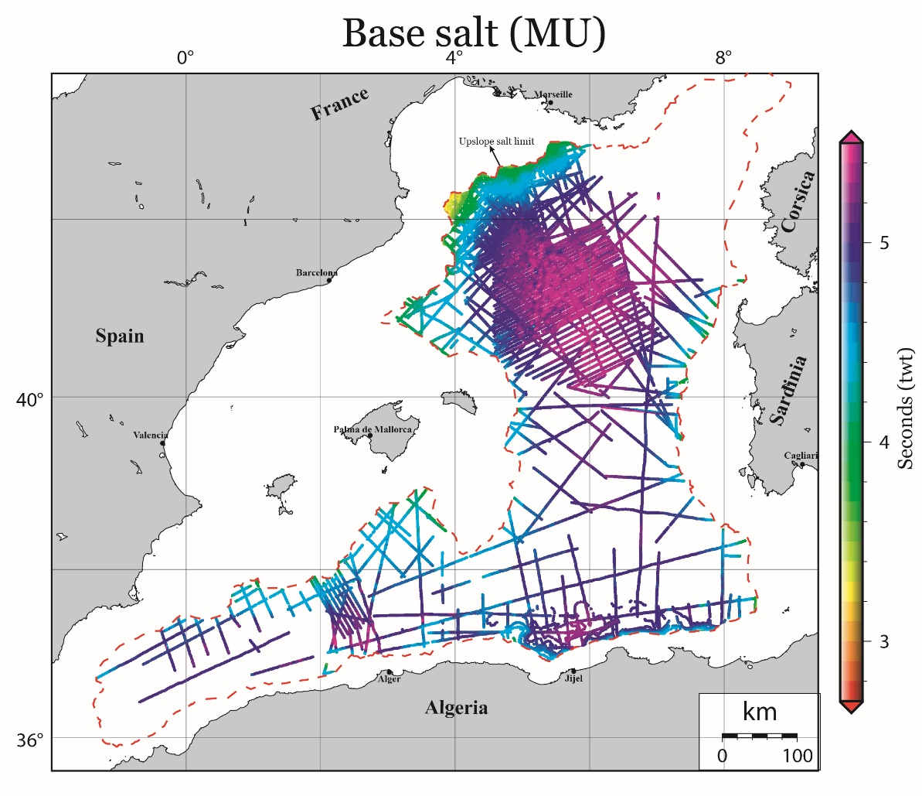
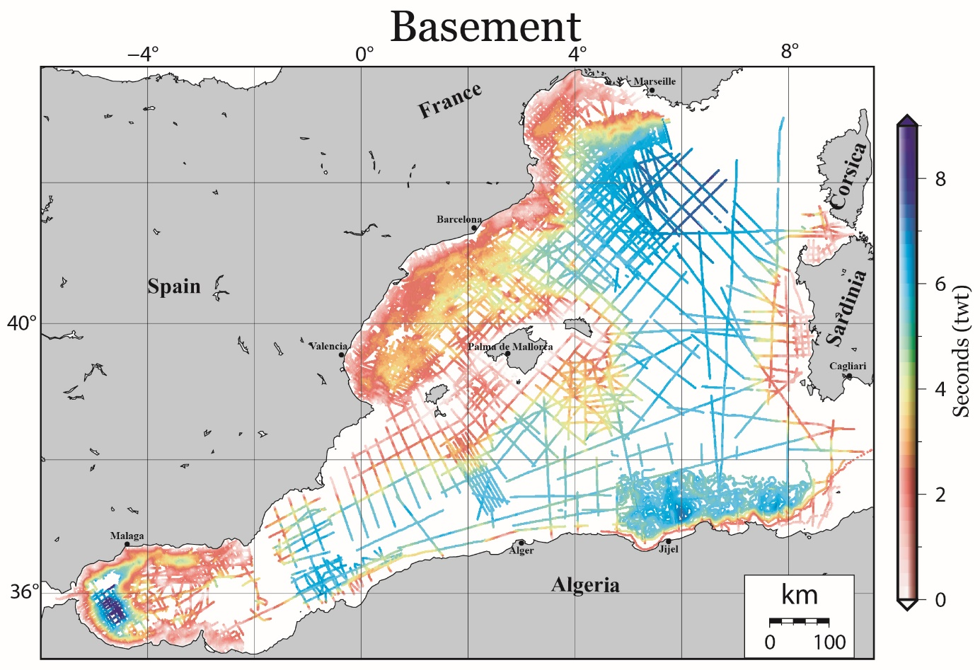
Figure 4. Base salt (Base MU) isobath map. The NE Algerian margin interpretation comes from Arab, (2016). Upslope salt (MU) limit is from Bellucci et al., (submitted).
Figure 3. Acoustic basement isobath map. The NE Algerian margin interpretation comes from Arab, (2016).
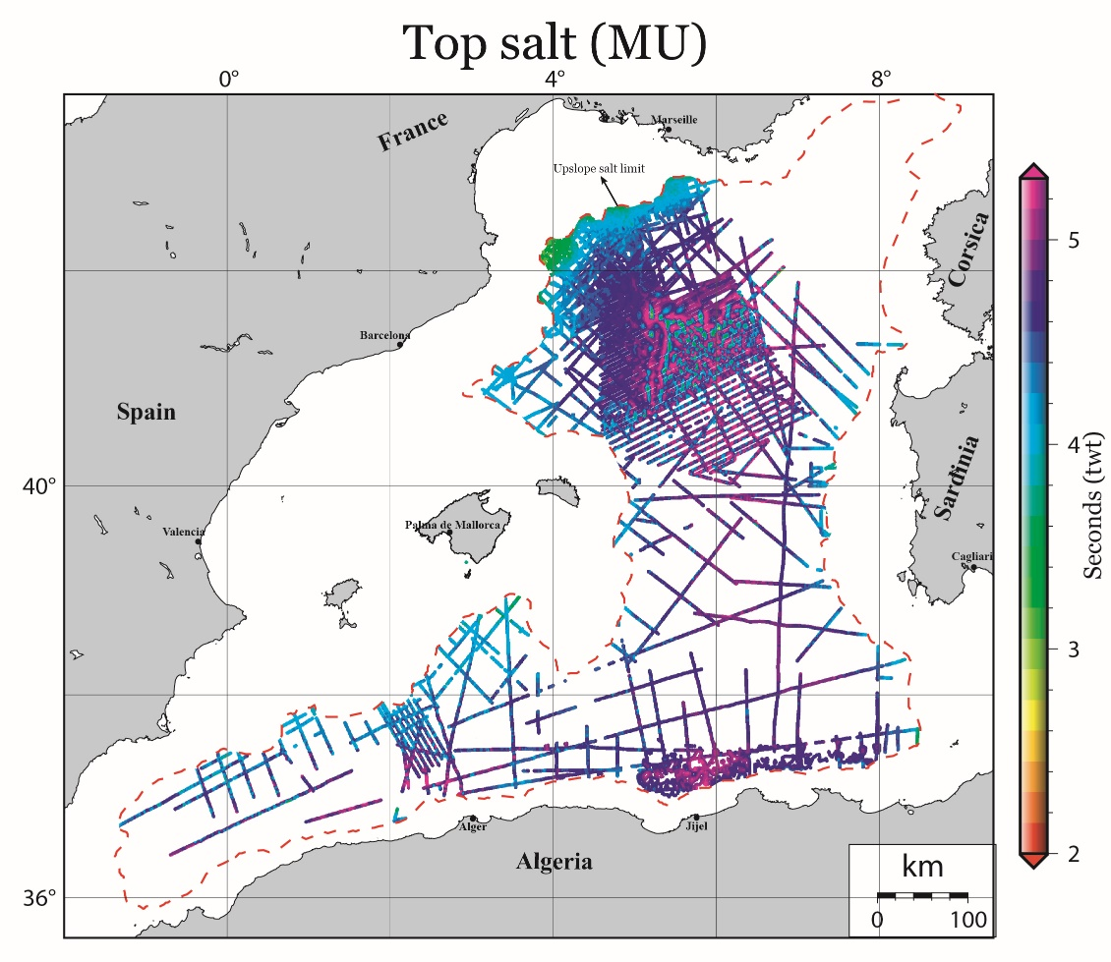
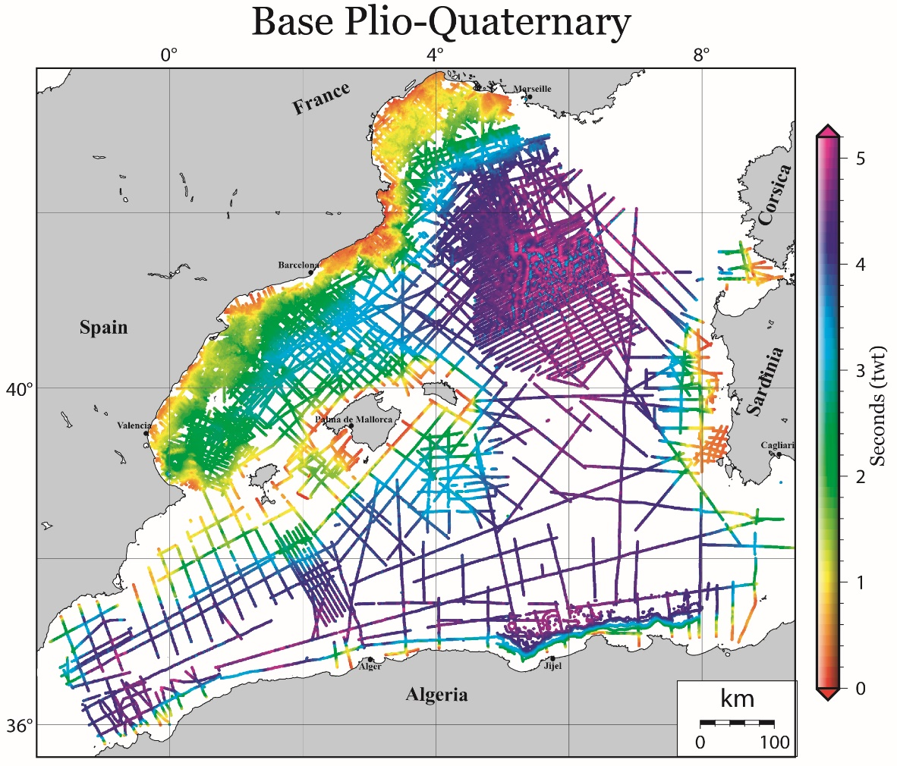
Figure 6. Base Plio-Quaternary isobath map. The NE Algerian margin interpretation comes from Arab, (2016).
Figure 5. Top salt (Top MU) isobath map. The NE Algerian margin interpretation comes from Arab, (2016). Upslope salt (MU) limit is from Bellucci et al., (submitted).

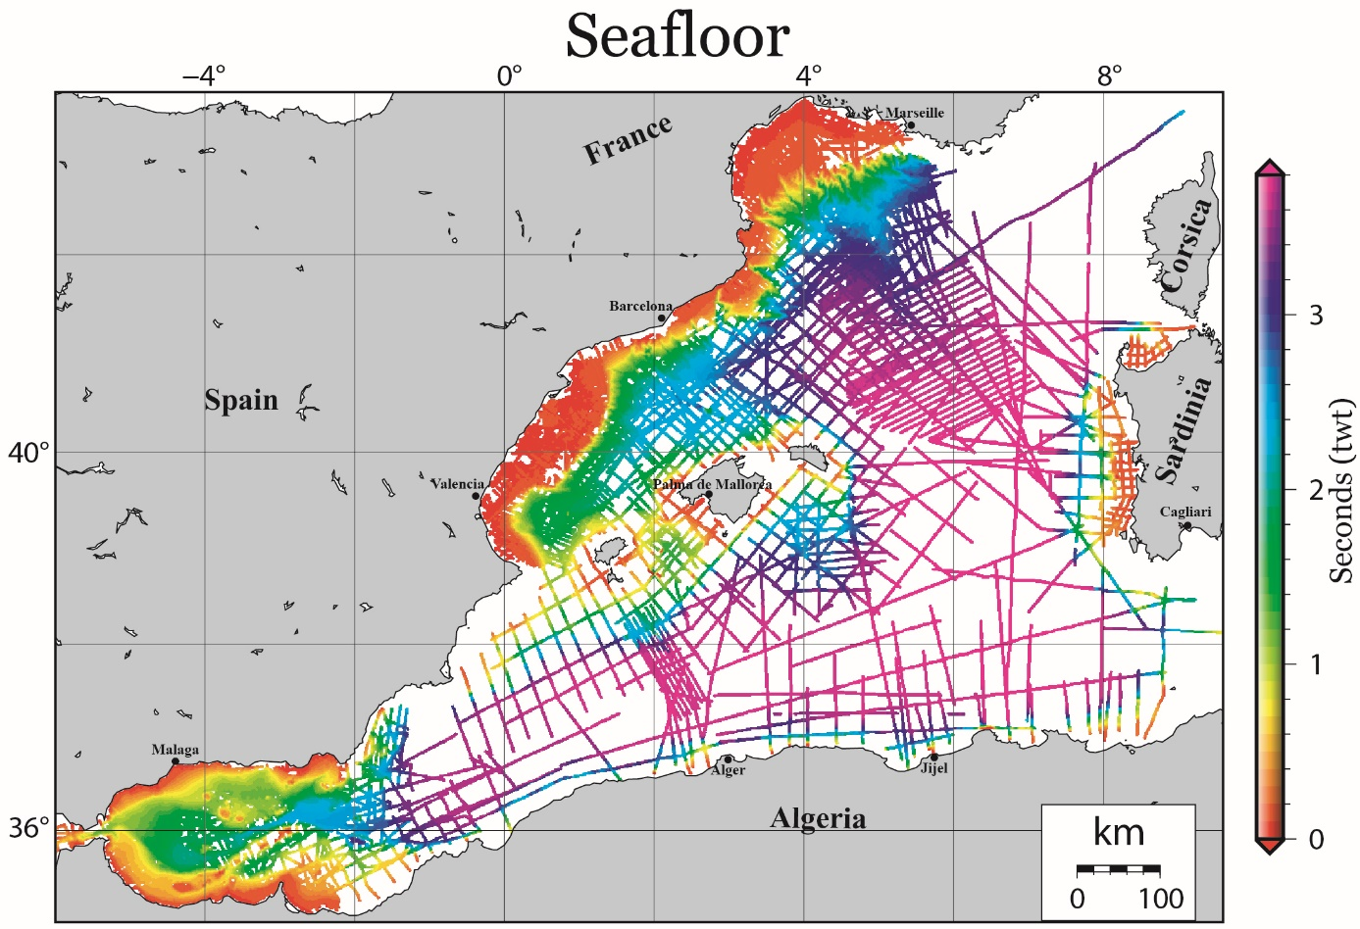
Figure 7. Seafloor isobath map.

Authors’ contribution:
This project was designed by DA and realised by MB with active participation of RP. The data organisation and setting up was made by JP.
Seismic interpretation for this data compilation
Alboran basin: the interpretation was made by DDC during his PhD (Do Couto, 2014) with the collaboration of CG and JP.
Algerian deep basin: the interpretation was made by MB during his PhD under the supervision and collaboration of DA, MR, MM, EL and RP. The western part was interpreted by AM.
Balearic Promontory and South Balearic margin: the South Balearic margin interpretation was made by MB during his PhD with the collaboration and supervision of RP, DA, MR, MM and EL. The interpretation in the south of Menorca and between Mallorca and Ibiza was made by FR (Raad et al., 2020) during his PhD under the supervision of AM and JL.
Gulf of Lion: the interpretation was made by MR, FB and EL during their PhD (Rabineau, 2001; Bache, 2008; Leroux, 2012) with the supervision and collaboration of MR, CG and DA.
Liguro-Provençal basin: the interpretation was made by MB, EL, FB and RP during their PhD (Bache, 2008; Leroux, 2012; Pellen, 2016) with the collaboration of MR, CG, DA and MM.
North-East Algerian margin: the interpretation was made by MB and RP during their PhD and Post-Doc, respectively, with the supervision and collaboration of MR, DA, MM and EL. The interpretation was complemented by digitalisation from the thesis of Arab, (2016).
Valencia and Menorca basins: the interpretation was made by RP during his thesis (Pellen, 2016) under the supervision of MR and DA. The Catalan margin was interpreted by MG Post-Doc (Garcia et al., 2011) with the collaboration of DA, MB and AM.
Western Sardinian margin: the interpretation was made by MB during his PhD with the collaboration and supervision of ADB, EL, MR, RP, MM and DA. The north Sardinian margin was supplemented by interpretation of AM.

Data organisation and supply
Alboran basin: refer to Do Couto, (2014) for the data source.
Algerian deep basin: AC provided part of the dataset. Refer to Leroux et al., (2019) for other data source.
Balearic Promontory and South Balearic margin: refer to Driussi, (2014), Dal Cin et al., (2016); Pellen, (2016) and Raad et al., (2020). Additional data by SIGEOF Spanish site and Schlumberger.
Gulf of Lion: refer to Gorini, (1993), Maillard, (1993), Rabineau, (2001), Lofi, (2002), Bache, (2008) and Leroux, (2012).
Liguro-Provençal basin: refer to Gorini, (1993), Maillard, (1993), Rabineau, (2001), Bache, (2008), Leroux, (2012), Geletti et al., (2014), Bellucci, (M2, 2017).
North-East Algerian margin: refer to Arab, (2016) and Leroux et al., (2019).
Valencia and Menorca basins: refer to Maillard, (1993), Garcia et al., (2011), Driussi, (2014) and Pellen, (2016). Additional data by SIGEOF Spanish site and Schlumberger.
Western Sardinian margin: refer to Geletti et al., (2014), Dal Cin et al., (2016) and Bellucci, (M2, 2017). Additional data by VIDEPI Italian site.

References associated to the data compilation
Arab, M. (2016). Analyse des systèmes pétroliers de l’offshore algérien oriental: Quantification, modélisation stratigraphique et thermique (Doctoral dissertation, Université de Bretagne Occidentale (UBO); Université des Sciences et Technologie Houari Boumedienne (USTHB), Alger, Algérie; Université Bretagne Loire). https://tel.archives-ouvertes.fr/tel-01459675
Bache, F. (2008). Evolution Oligo Miocène des marges du micro océan Liguro-Provençal (Doctoral dissertation, Université de Bretagne Occidentale). https://tel.archives-ouvertes.fr/tel-00326616
Bellucci, M., Aslanian, D., Moulin, M., Rabineau, M., Leroux, E., Pellen, R., Poort, J., Del Ben, A., Gorini, C., Camerlenghi, A. Salt morphologies and crustal segmentation relationship: new insights from well-known salt-bearing margins, submitted to ESR, 11th Jan 2021
Bellucci, M., Del Ben, A., Geletti, R., Forlin, E., Rabineau, M., Leroux, E., Aslanian D. & Pellen, R. (Master thesis, 2017). Interpretation of seismic profiles in the Western Mediterranean Sea. .
Berne, S., & Gorini, C. (2005). The Gulf of Lions: An overview of recent studies within the French 'Margins' programme. Marine and petroleum geology, 22(6-7), 691-693.
Dal Cin, M., Del Ben, A., Mocnik, A., Accaino, F., Geletti, R., Wardell, N., Zgur F., & Camerlenghi, A. (2016). Seismic imaging of Late Miocene (Messinian) evaporites from Western Mediterranean back-arc basins. Petroleum Geoscience, 22(4), 297-308.
Do Couto, D., Popescu, S. M., Suc, J. P., Melinte-Dobrinescu, M. C., Barhoun, N., Gorini, C., & Auxietre, J. L. (2014). Lago Mare and the Messinian salinity crisis: evidence from the Alboran Sea (S. Spain). Marine and Petroleum Geology, 52, 57-76. https://tel.archives-ouvertes.fr/tel-01148777
Driussi, O. (2014). Évolution de la région Baléares (Méditerranée occidentale) du néogène à l'actuel: aspects géodynamiques et paléo-environnementaux (Doctoral dissertation, Université de Toulouse, Université Toulouse III-Paul Sabatier). https://tel.archives-ouvertes.fr/tel-01118302
Etheve, N., de Lamotte, D. F., Mohn, G., Martos, R., Roca, E., & Blanpied, C. (2016). Extensional vs contractional Cenozoic deformation in Ibiza (Balearic Promontory, Spain): Integration in the West Mediterranean back-arc setting. Tectonophysics, 682, 35-55.
Garcia, M., Maillard, A., Aslanian, D., Rabineau, M., Alonso, B., Gorini, C., & Estrada, F. (2011). The Catalan margin during the Messinian Salinity Crisis: Physiography, morphology and sedimentary record. Marine Geology, 284(1-4), 158-174.
Geletti, R., Zgur, F., Del Ben, A., Buriola, F., Fais, S., Fedi, M., Forte E., Mocnik A., Paoletti V., Pipan M., Ramella R., Romeo R., & Romi, A. (2014). The Messinian Salinity Crisis: new seismic evidence in the West-Sardinian Margin and Eastern Sardo-Provençal Basin (West Mediterranean Sea). Marine Geology, 351, 76-90.
Gorini C. (1993) Géodynamique d’une marge passive: le Golfe du Lion (Méditerranée
Occidentale). Doctorat, Université Paul Sabatier, Toulouse, 256 pp.
Gorini, C., Montadert, L., & Rabineau, M. (2015). New imaging of the salinity crisis: Dual Messinian lowstand megasequences recorded in the deep basin of both the eastern and western Mediterranean. Marine and Petroleum Geology, 66, 278-294.
Krijgsman, W., Hilgen, F. J., Raffi, I., Sierro, F. J., & Wilson, D. S. (1999a). Chronology, causes and progression of the Messinian salinity crisis. Nature, 400(6745), 652-655.
Leroux, E. (2012). Quantification des flux sédimentaires et de la subsidence du bassin Provençal (Doctoral dissertation, Université de Bretagne occidentale-Brest). https://tel.archives-ouvertes.fr/tel-00790852
Leroux, E., Aslanian, D., Rabineau, M., Gorini, C., Rubino, J.-L., Poort, J., Suc, J.-P., Bache, F. and Blanpied, C., et al. (2019). Atlas of the stratigraphic markers in the western mediterranean with focus on the Messinian, Pliocene and Pleistocene of the Gulf of Lion. CGMW (Commision for the Geological Map of the World) editor, 73p + CD.
Leroux, E., Rabineau, M., Aslanian, D., Gorini, C., Molliex, S., Bache, F., Robin C., Droz L., Moulin M., Poort J., Rubino J.P., & Suc, J. P. (2017). High‐resolution evolution of terrigenous sediment yields in the Provence Basin during the last 6 Ma: relation with climate and tectonics. Basin Research, 29(3), 305-339.
Lofi, J. (2002). La crise de salinité messinienne: conséquences directes et différées sur l'évolution sédimentaire de la marge du Golfe du Lion. Diss. Lille 1. www.theses.fr/2002LIL10034
Lofi J., Déverchère, J., Gaullier, V., Gillet, H., Gorini, C., Guennoc, P., Loncke, L., Maillard, A., Sage, F., Thinon, I., (2011a). Seismic atlas of the “messinian salinity crisis” markers in the mediterranean and black seas. Comm. Geol. Map World Mem. SoC. Géol. de France, Nouvelle Sér. 72.
Lofi, J. (2018). Seismic Atlas of the Messinian Salinity Crisis markers in the Mediterranean Sea-Volume 2 (Vol. 181, pp. 1-72). Société Géologique de France.
Maillard, A. (1993). Structure et riftogénèse du golf de Valence (Méditerranée Occidentale) (Doctoral dissertation, Atelier national de reproduction des thèses).
Mauffret, A., 1976, Étude géodynamique de la marge des îles Baléares (Thèse d'État thesis), Univ. Paris VI.
Pellen, R. (2016). Géodynamique et impact de la crise d'érosion et de salinité Messinienne sur les transferts sédimentaires (bassins de Valence et Adriatique) (Doctoral dissertation, Université Bretagne Loire). https://tel.archives-ouvertes.fr/tel-01651341
Pellen, R., Aslanian, D., Rabineau, M., Leroux, E., Gorini, C., Silenziario, C., Blanpied C.,& Rubino, J. L. (2016). The Minorca Basin: a buffer zone between the Valencia and Liguro‐Provençal Basins (NW Mediterranean Sea). Terra Nova, 28(4), 245-256.
Pellen, R., Aslanian, D., Rabineau, M., Suc, J. P., Gorini, C., Leroux, E., Blanpied, C., Silenziario, C., Popescu, S.M. & Rubino, J. L. (2019). The Messinian Ebro River incision. Global and Planetary Change, 181, 102988.
Raad, F., Lofi, J., Maillard, A., Tzevahirtzian, A., & Caruso, A. (2021). The Messinian Salinity Crisis deposits in the Balearic Promontory: an undeformed analog of the MSC Sicilian basins? Marine and Petroleum Geology, 124, 104777.
Rabineau, M. (2001). Un modèle géométrique et stratigraphique des séquences de dépôts quaternaires sur la marge du Golfe du Lion: enregistrement des cycles climatiques de 100 000 ans (Doctoral dissertation, Université de Rennes1). https://tel.archives-ouvertes.fr/tel-00136517
Rabineau, M., Cloetingh S.,Kuroda J., Aslanian D., Droxler A., Gorini C., Garcia-Castellanos D., Nolet G., Moscariellio A., Hello Y., Burov E., Sierro F., Lirer F., Roure F., Pezard P., Mart Y., Camerlenghi A., and the GOLD and DREAM Working Groups, Probing connections between deep earth and surface processes in a land-locked ocean basin transformed into a giant saline basin: the Mediterranean DREAM-GOLD project, Marine & Petroleum Geology, Special Vol. , 2015.
SIGEOF – Sistema de Informacion Geofisica IGME https://info.igme.es/sigeof/default.html?ambito=BD_GEOF_SIS_SEGY
VIDEPI Project https://www.videpi.com/videpi/videpi.asp
Wessel, P., & Smith, W. H. (1995). New version of the generic mapping tools. Eos, Transactions American Geophysical Union, 76(33), 329-329.

