Reconstruction of land-sea DTMs at several geological periods: Example of the Mozambique Channel and Madagascar.
Pellen Romain^{*1}, Aslanian Daniel¹, Rabineau Marina¹
1 Geo-Ocean, Univ Brest, CNRS, Ifremer, UMR6538, F-29280 Plouzane, France

Abstract
We present here the methodology used to reconstruct six paleobathymetric and paleotopographic grids for six periods of age (~70, 66-60, ~45, 36-30, ~20, 12-5 Ma) based on the compilation of published onshore and offshore structural and sedimentary data. We provide xyz format (WGS84, z in metres) of the reconstructed geometry of the Mozambique Channel as well as the paleo-elevations of the East Africa and Madagascar landscapes. The compilation is beneficial both to the scientific community working in sedimentation, tectonics and for oceanographic modelling.
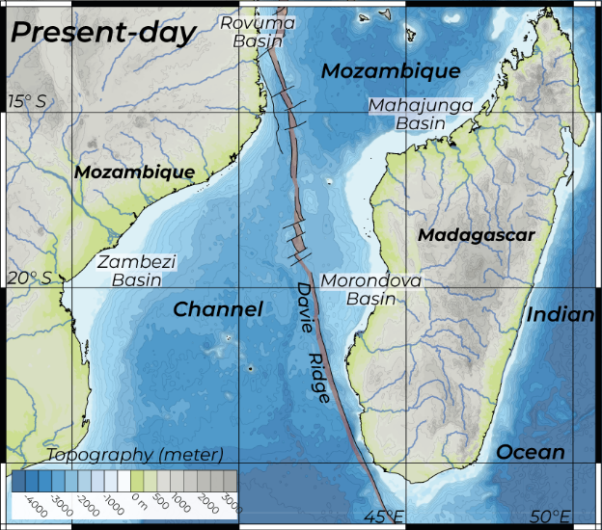
Introduction
During the PAMELA (Passive Margins Exploration Laboratories) project led by Ifremer and Total, 10 oceanographic campaigns were conducted (224 days at sea) between 2014 and 2017, and three onshore geological studies (for 50 days on land) in 2017 and 2018. This project involved sedimentary, tectonic, kinematic and paleoenvironmental studies of the history of the Mozambique Channel.
The results obtained from this intensive and extensive study, involving more than 100 researchers, present a complex and dynamic picture of the topography of the Mozambique Channel. As a result of this concentrated achievement, we were able to compile and provide paleobathymetric and paleotopographic grids for six periods of age. This article presents the methodology used to constrain the paleo-topography of the Mozambique Channel, which forms a more than 400-km-wide maritime corridor at its narrowest point, between Africa and Madagascar (Figure 1).
Figure 1: Present-day physiographic map of the Mozambique Channel and surrounding landscape.
Global setting
The Mozambique Channel exhibits a major, 1200-km-long, tectonic feature, the Davie Ridge, inherited from the southward motion of the Antarctica-Madagascar plates during Mesozoic time (~165 – 120 Ma; Thompson et al., 2019). This N170-oriented feature segments the Mozambique Channel into two parts: the Rovuma and Zambezi basins to the west, and the Somalia Basin to the east, including the Mahajunga Basin in north-west Madagascar and the Morondava Basin (e.g. Heirtzler and Burroughs, 1971; Coffin and Rabinowitz, 1987; Davis et al., 2016; Thompson et al., 2019). As a “second-order intra-plate boundary” (Olivet et al. 1984), this feature is highly sensitive to the kinematic changes (related magmatism events and uplifts), that impact this part of the Indian Ocean.⁠
During the considered period (75-0Ma), three global revolutions occurred:
- at the Cretaceous-Paleogene boundary, marked by a mass extinction, the Deccan magmatism event, major ocean acidification (Henehan et al. 2019), the Chicxulub impact (Renne et al, 2013), and global plate reorganisation (Moulin & Aslanian, 2010)
- at Eocene–Oligocene, with mass extinction (The Grande Coupure), major climatic change, volcanic activity, several large meteorite impacts… and global plate reorganisation
- at Upper Miocene-Messinian time, the severe ecological crisis with the onset of the Messinian Salinity Crisis in the Mediterranean area, but also worldwide rejuvenated volcanism, sedimentary flux increase, global plate reorganisation shown by the reorientation of transform fracture zones, carbonatite deposits, significant relief change (Leroux et al., 2018).
The different events of each period argue in favour of global geodynamic events drawing a series of global cyclical events. (Moulin & Aslanian, 2010; Leroux et al, 2018). These events have a greater or lesser impact on the whole planet, and particularly on the sensitive second-order intra-plate boundaries, such as the Davie ridge.
Methodology
The first step (Figure 2) includes the compilation of all data and results on kinematics, structure, and the sedimentary and morphological evolution of the channel, Madagascar and southern Africa. This work was performed using the free software QGis and PLACA4D (Pelleau et al., 2015).
On land, we incorporated information on the paleo-terraces and fluvial systems estimated from the work of Guillocheau et al. (2012), Ponte (2018) and Delaunay (2018) studies. Once the preserved paleo-surfaces are identified we can propose paleo-relief estimations of different periods (Cretaceous-Paleocene, Oligocene, and Upper Miocene). As a result of, in particular, the PAMELA (Passive Margins Exploration Laboratories) research programme, seven generations of stepped flattening surfaces have been defined over East Africa and Madagascar, ranging from the Jurassic to the Quaternary.
At sea, we compiled information from the PAMELA oceanographic campaigns and the work of Thompson et al (2019), Delaunay (2018), Ponte et al (2019), Moulin et al (2020), Leprêtre et al (2021). The use of PLACA4D software allowed us to compare the data associated with the different geological periods and to identify the periods of sedimentation and structural rupture.
Step 2 consisted in synthesising information with a simple classification for paleo-topography.
At Sea: Sub-aerial, shallow, continental slope with submarine canyon systems, and a deep environment. Sedimentary depocenter limits provide information on the morphology of the deep domains. We have also highlighted potential magmatic edifices.
On land: Each break-up periods is associated with the generation of a new paleo-surface, which has been subject to fluvial erosion. Their inclinations and elevations, associated with the identification of volcanic edifices and their periods of activity, provide information on the uplift direction and axis that affected Madagascar and Southern Africa.
Step 3. The shapes of land and sea features and their possible heights and depths were then estimated (Figure 2, step 3). From the data of previous research works, the shapes of geological objects are suggested by their maximum extensions.
On land, Delaunay (2018) and Ponte (2018) estimated an average relief altitude for the Late Cretaceous-Paleocene, Oligocene and Upper Miocene periods at respectively 600 m, 800 m and 1100 m.
At sea, we need first to take into account the normal thermal evolution of the oceanic crust. After delineating the oceanic domain, we developed an age model for each oceanic plate, which were then incorporated into a kinematic model with PLACA4D and constrained by the Eulerian poles of Thompson et al. (2019). This methodology has allowed us to track the plate motions leading to the birth of the oceanic plates. The Watts and Steckler’s law (1981) was applied to the oceanic plates and provided a paleodepth estimation for each offshore domain between 180 and 0 Ma.v. The paleo-bathymetric reconstructions were then corrected with respect to the episodic magmatic events that produced the uplifts shown in the sedimentary sequences (presence of shallow carbonates, hiatuses, discordances). Several magmatic events have impacted this domain through time (Karoo ~180Ma, Movene-Bumeni ~145-135Ma; Madagascar Turonian trapps ~95Ma, Lutetian, Oligocene, Tortonian – Moulin et al., 2020; Leprêtre et al., 2021), producing bulges, uplifts and seamounts. Consistently low records of sedimentation (low deposition and/or low preservation due to erosion) between 120 and 23 Ma (Delaunay, 2018; Ponte et al., 2019) indicate the presence of a relatively consistent topographic high and/or deposition–erosion sequences. Moreover, occurrences of buried carbonate terraces sampled on several islands (Hall Bank, Sakalaves platform, Glorieuses) suggest that carbonate production started before or during the: the late Paleocene for Sakalaves platforms, Glorieuses, Juan de Nova Island, Leven-Castor highs; Rupelian-Langhian time for Bassas da India and Hall Bank; or Messinian-Pliocene time for the Comores archipelago on a volcanic basement (Courgeon et al., 2017; Leroux et al., 2020).
Step 4 The paleodepth maps produced by PLACA4D together with the geological features affecting the Mozambique Channel have led us to estimate and build isohypse curves with Didger software (Figure 2, step 4). We began with the reconstruction of the different isohypses associated with the break-up periods, at 66-60 Ma, 36-30 Ma and 12-5 Ma.
Between these geological periods, data show a deepening of the oceanic basins. We therefore produced numerical models by applying an average 500 m subsidence affecting the Davie Ridge and the surrounding islands. We also took into account the maximum extension of the marine domain along the continental shelves based on the compilation of Ponte (2018) and Delaunay (2018).

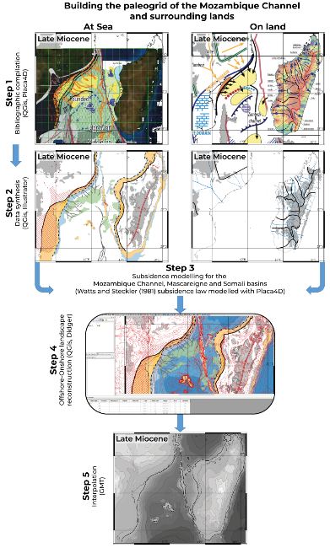
Figure 2: Five steps are applied to prepare and constrain a digital terrain model for one geological period. Here, we present the different steps and information used for the 12-5 Ma period.
Step 5 (Figure 2) consists of interpolating the isohypse curves with the Generic Mapping Tool (GMT) software (the code used is included in the supplementary material). The different maps resulting from this interpolation are shown in Figure 3. The grids are then extracted in xyz WGS84 format.
This work was included in a series of papers aiming to study the origin of Madagascar's faunistic (Masters et al., 2020, 2021, Aslanian et al., 2022) and floristic evolution (Génin et al., 2022).

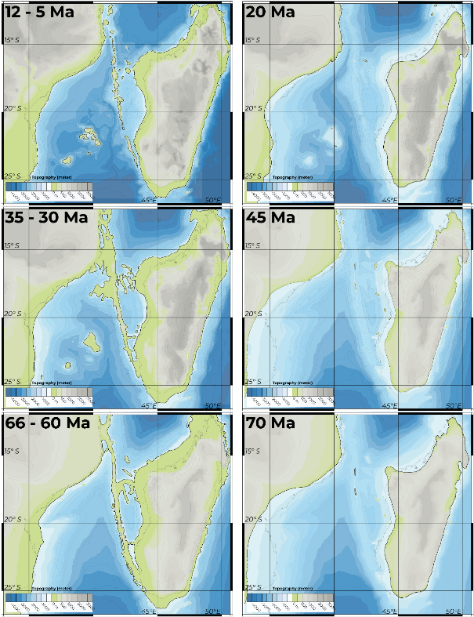
Figure 3: Illustration of the six paleo grids illustrating intermittent bridges (5-12 Ma, 30- 35 Ma, 60-66 Ma) and inter-stage periods (each map illustrating a snapshot of these periods (i.e. 12-30 Ma, 35-60Ma, 66 – 84 Ma)) reconstructed from the compilation of onshore and offshore data.

References
Aslanian, D., Pellen, R., Masters, J., Génin, F., Rabineau, M., Mazza, P., Moulin, M., Thompson, J., Siuc, J.-P., Popescu, S.-M., Fauquette, S., Linol, B., Doucouré, M., Huck, T., Penven, P., Le Hir, T., and Zhang, Y., 2022, L'endémisme de Madagascar: démonstration d'une méthode holistique: Pangea Infos, v. 42.
Coffin, M.F. and Rabinowitz, P.D., 1987. Reconstruction of Madagascar and Africa: Evidence from the Davie Fracture Zone and western Somali Basin. Journal of Geophysical Research, 92(B9): 9385-9406.
Courgeon, S., Jorry, S.J., Jouet, G., Camoin, G., BouDagher-Fadel, M.K., Bachèlery, P., Caline, B., Boichard, R., Révillon, S., Thomas, Y., Thereau, E., and Guérin, C., 2017, Impact of tectonic and volcanism on the Neogene evolution of isolated carbonate platforms (SWIndian Ocean): Sedimentary Geology, v. 355, p. 114-131.
Davis, J.K., Lawver, L.A, Norton, I.O., Gahagan, L.M., 2016. New Somali Basin magnetic anomalies and a plate model for the early Indian Ocean. Gondwana Research 34, 16–28.
Delaunay, A. (2018). Les mouvements verticaux de Madagascar (90–0 Ma): Une analyse couplée des formes du relief et de l'enregistrement sédimen- taire des marges ouest malgaches. PhD thesis, Université́ de Rennes 1. https://doi.org/10.13140/RG.2.2.35631.69283
Génin, F., Mazza, P.P.A., Pellen, R., Rabineau, M., Aslaian, D., Masters, J.C., accepted. Co-evolution assists geographic dispersal: the case of Madagascar. Biological Journal of the Linnean Society.
Guillocheau, F., Rouby, D., Robin, C., Helm, C., Rolland, N., Le Carlier de Veslud, C., Braun, J., 2012. Quantification and causes of the terrigeneous sediment budget at the scale of a continental margin: a new method applied to the Namibia-South Africa margin. Basin Res. 24 (1), 3–30.
Heirtzler, T.R. and Burroughs, R.W., 1971. Madagascar's paleo-position. New data from the Mozambique Channel. Science 174, 488-490.
Leprêtre, A. Schnurle, P., Evain, M., Verrier, F., Moorcroft, D.,. de Clarens, P., Corela, C., Afilhado, A., Loureiro, A., Leroy, S., d’Acremont, E., Thompson, J., Aslanian D., Moulin M. and MOZ3/5 Team, Deep structure of the North Natal Valley (Mozambique) using combined wide‐angle and reflection seismic data. Journal of Geophysical Research: Solid Earth, 126, e2020JB021171. https://doi.org/10.1029/2020JB021171
Leroux, E., Counts, J., Jorry, S., Jouet, G., Révillon, S., BouDagher-Fadel, M., Courgeon, S., Berthod, C., Ruffet, G., Bachèlery, P., and Grenard-Grand, E., 2020, Tectonic, climate, and oceanographic changes since the Cretaceous in the Somali Basin (SW Indian Ocean): New insights from the Glorieuses seamount (Eparse Islands) and its surrounding deep basin: Marine Geology.
Masters, J., Génin, F., Zhang, Y., Pellen, R., Huck, T., Mazza, P. P. A., Rabineau, M., Doucoure, M. and Aslanian, D., Biogeographic mechanisms involved in the colonisation of Madagascar by African vertebrates: rifting, rafting and runways, Journal of Biogeography, December 2020, 00:1–19. DOI: 10.1111/jbi.14032.
Masters, J., Génin, F., Pellen, R., Mazza, P., Zhang, Y., Huck, T., Rabineau, M., and Aslanian, D., 2021, Geodispersal as a Biogeographic Mechanism for Cenozoic Exchanges between Madagascar and Africa: The natural History of Madagascar (2nd Edition).
Matias, L. M., Olivet, J.-L., Aslanian, D., & Fidalgo-González, L. (2005). PLACA: A white box for plate reconstruction and best-fit pole determination. Computers and Geosciences, 31, 437–452. https://doi.org/10.1016/j.cageo.2004.09.019
Moulin, M., Aslanian, D., Evain, M., Leprêtre, A., Schnurle, P., Verrier, F., Thompson, J., De Clarens, P., Dias, and the PAMELA-MOZ35 team, Gondwana breakup and passive margin genesis: Messages from the Natal Valley, Terra Nova, 32:205–214. 2020. https://doi.org/10.1111/ter.12448
Olivet J. L., Bonnin J., Beuzart P. et Auzende J. M., 1984. —Cinématique de l'Atlantique Nord et Central.— Rapp. Sci. Tech. C.N.E.X.O., v. 54, 108 p.
Pelleau, P., Aslanian, D., Matias, L., Moulin, M., Augustin, J.-M., Quemener, G., & Poncelet, C. (2015). Placa4D freeware: A new interactive tool for palinspastic reconstruction in 3D. American Association of Petroleum Geologists Congress.
Ponte, J.-P. (2018). La marge africaine du canal du Mozambique (le sys- tème turbiditique du Zambèze): Une approche "Source to Sink" au Méso-Cénozoïque. Thèse de doctorat - Université de Bretagne Loire. Retrieved from https://hal-insu.archives-ouvertes.fr/ tel-01865479
Ponte, J.-P., Robin, C., Guillocheau, F., Popescu, S.-M., Suc, J.-P., Dall'Asta, M., Melinte-Dobrinescu, M.C., Bubik, M., Dupont, G., and Gaillot, J., 2019, The Zambezi delta (Mozambique channel, East Africa): High resolution dating combining bio- orbital and seismic stratigraphies to determine climate (paleoprecipitation) and tectonic controls on a passive margin: Marine and Petroleum Geology, v. 105, p. 293-312.
Renne, P. R.; Deino, A. L.; Hilgen, F. J.; Kuiper, K.F., Mark, D.F., Matchell, W.S., Morgan, L.E., Mundil, R., Smit, J., 2013. Time Scales of Critical Events around the Cretaceous-Paleogene Boundary. Science. 339 (6120): 684–687.
Thompson, J.O., Moulin, M., Aslanian, D., de Clarens, P., and Guillocheau, F., 2019, New starting point for the Indian Ocean: Second phase of breakup for Gondwana: Earth-Science Reviews, v. 191, p. 26-56.
Watts, A., and Steckler, M., 1981, Subsidence and tectonics of Atlantic type continental margins: Oceanologica Acta, Colloque C3, Geology of Continental Margins, v. 4, p. 143-154.

