Shell/white fragment cover

Environnement > Substrat > Shells / White fragments > 0-10 %

MS/ 20180825T010747.622089Z.jpg
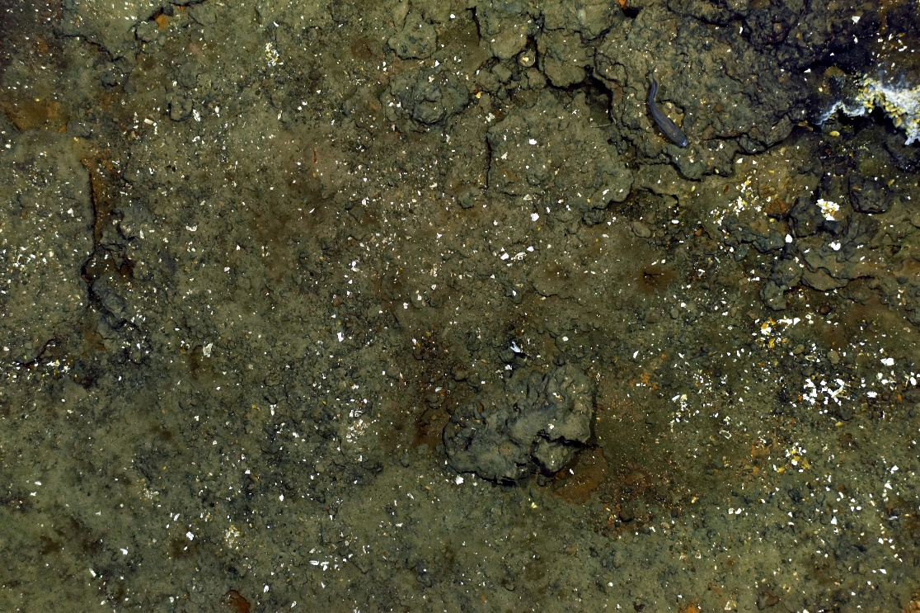
MS/ 20180825T010602.579501Z.jpg

Environnement > Substrat > Shells / White fragments > 10-50%

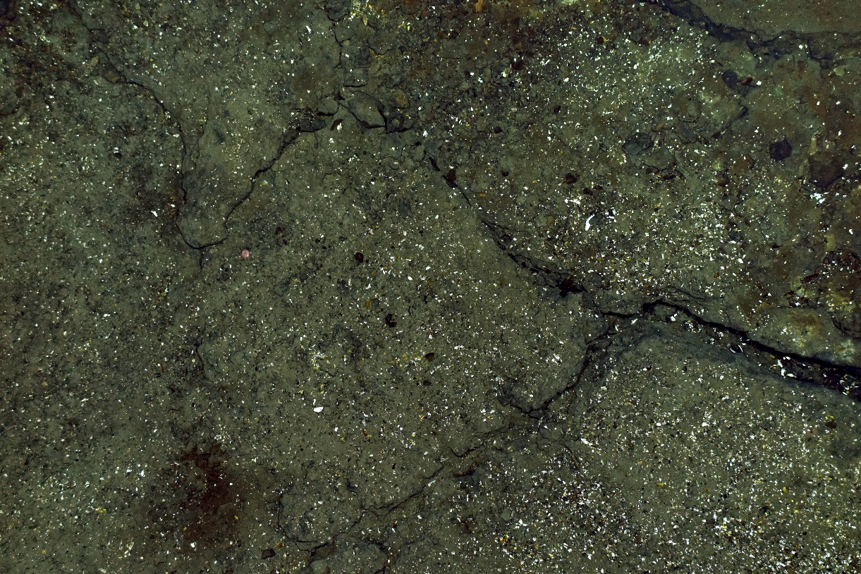
MS/20180825T012136.345949Z.jpg
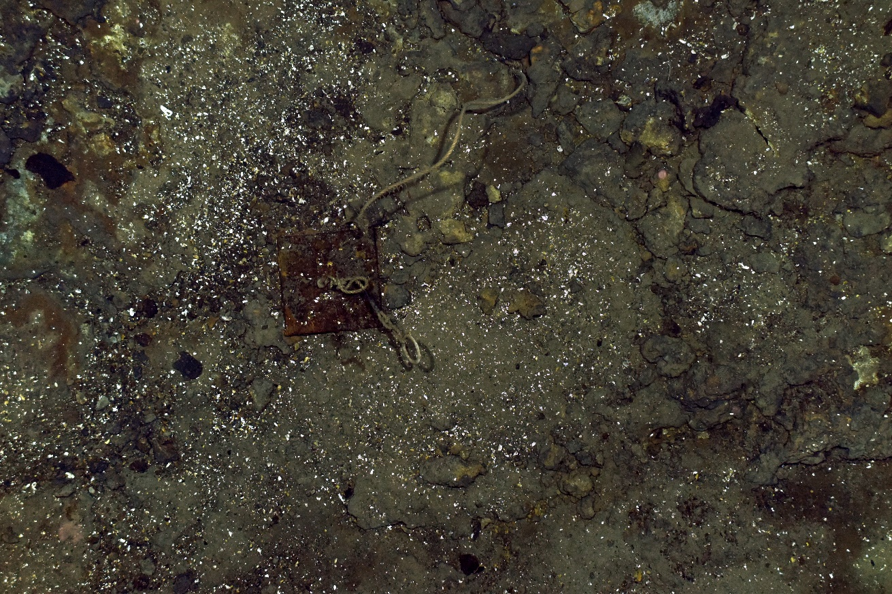
MS/ 20180825T023539.317813Z.jpg

Environnement > Substrat > Shells / White fragments > 50-100%
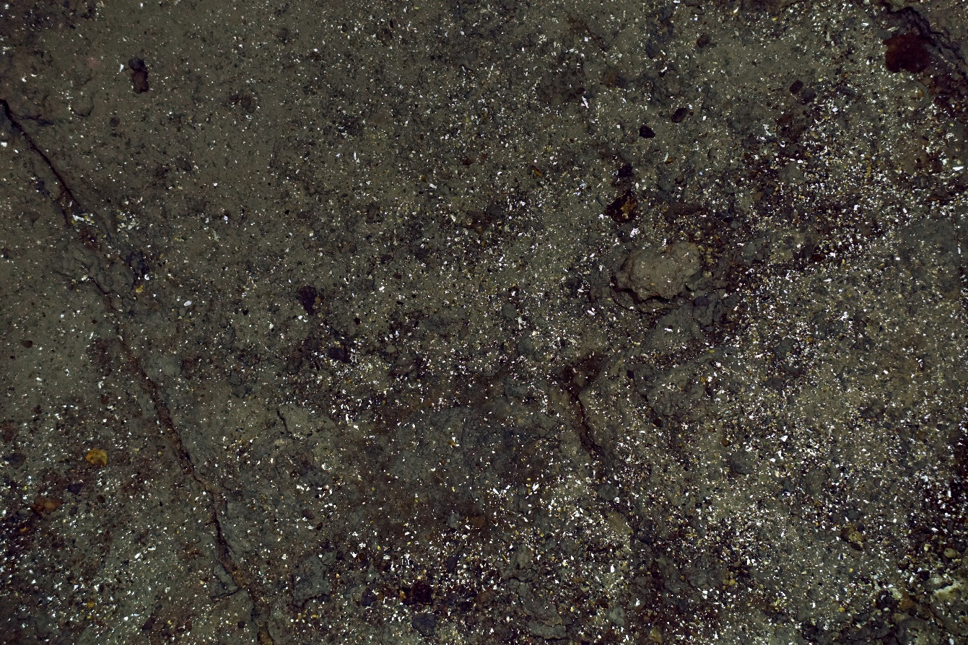
MS/ 20180825T013707.149377Z.jpg
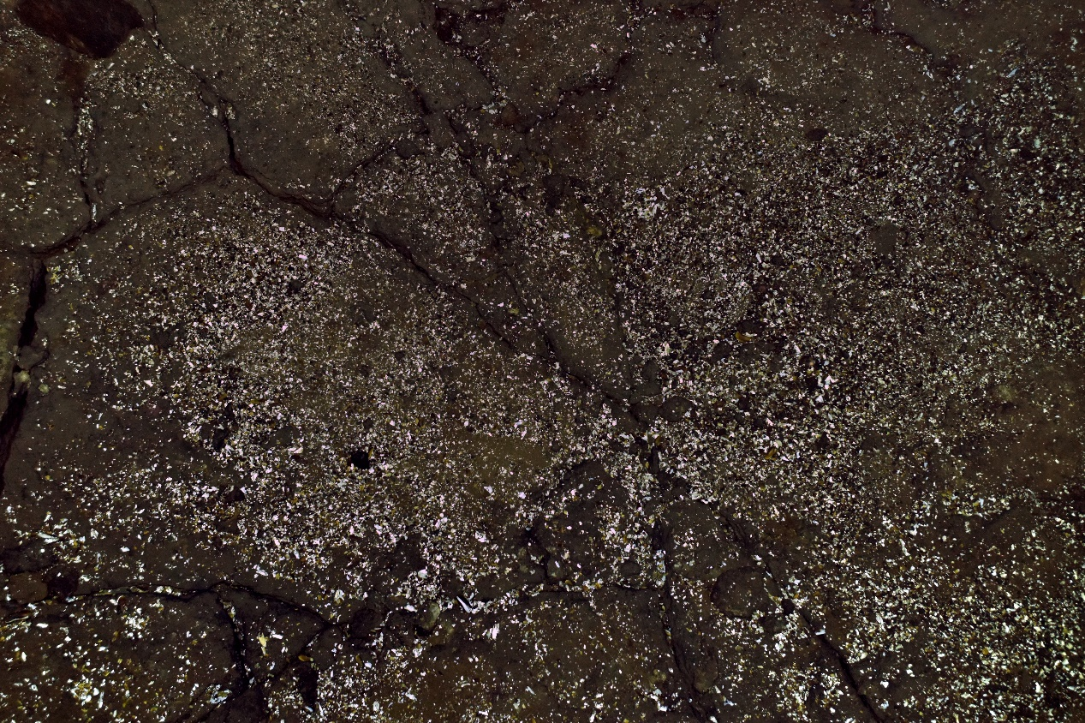
MS/ 20180825T022200.345940Z.jpg

Seabed lithology

Environnement > Substrat > Lithology > Soft substrate > Volcanoclastic

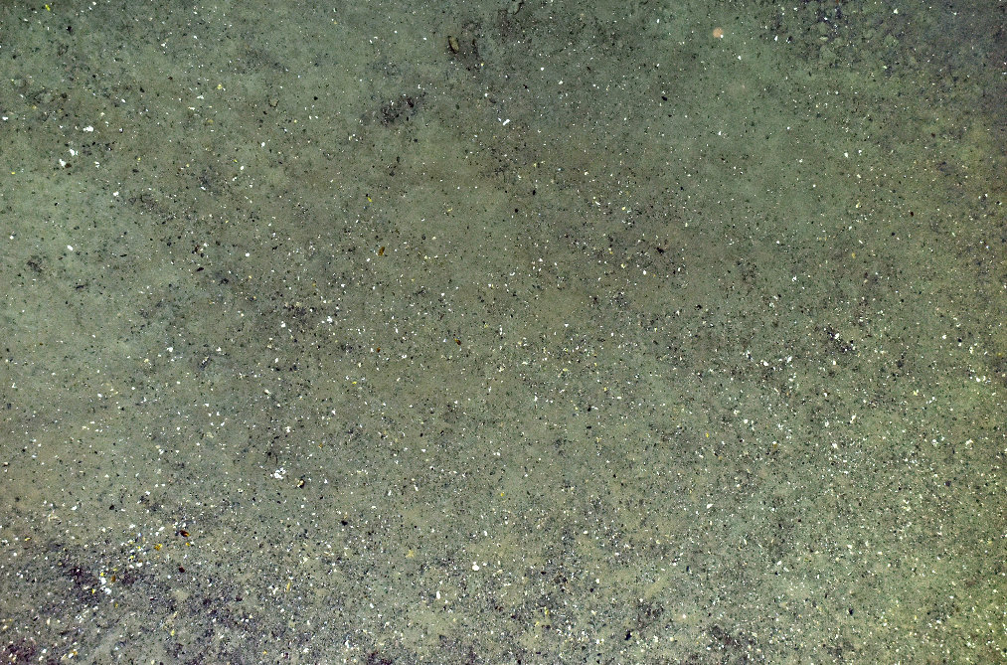
TE/20180819T054739.972295Z.jpg

Environnement > Substrat > Lithology > Hard substrate > Basalt
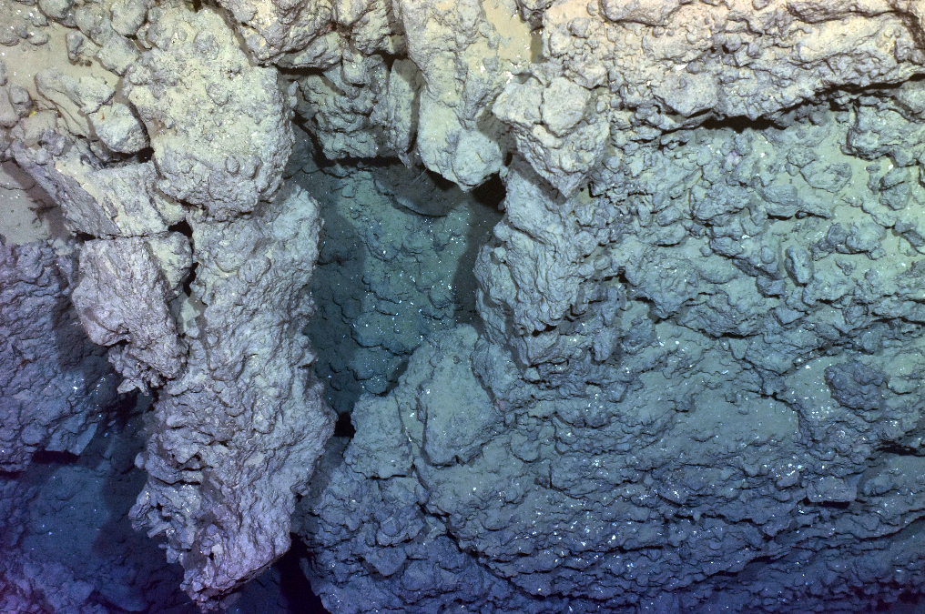
TE/20180819T052744.907543Z.jpg

Environnement > Substrat > Lithology > Hard substrate > Sulfurs
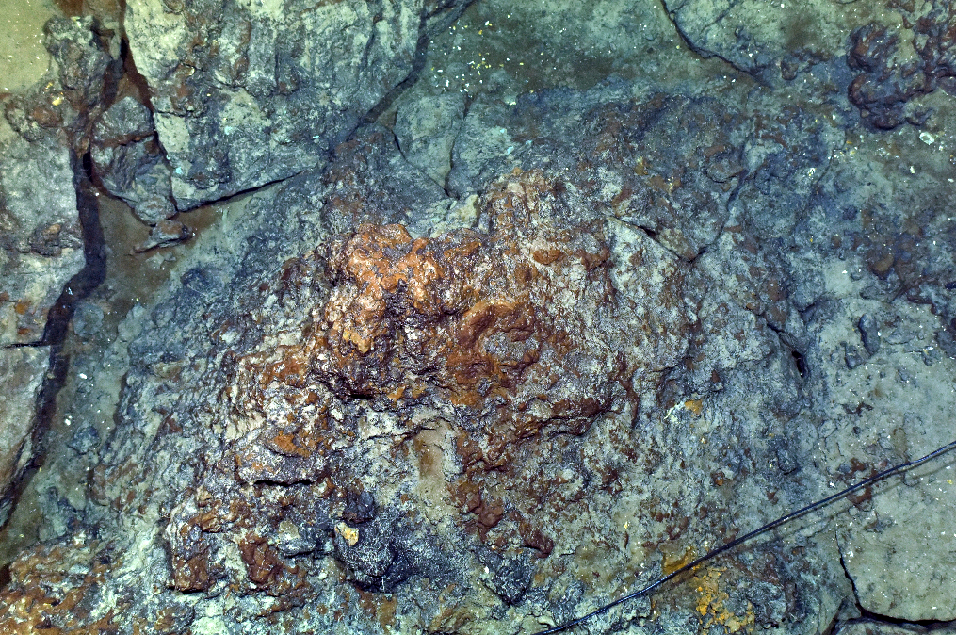
TE/20180818T032658.122290Z.jpg
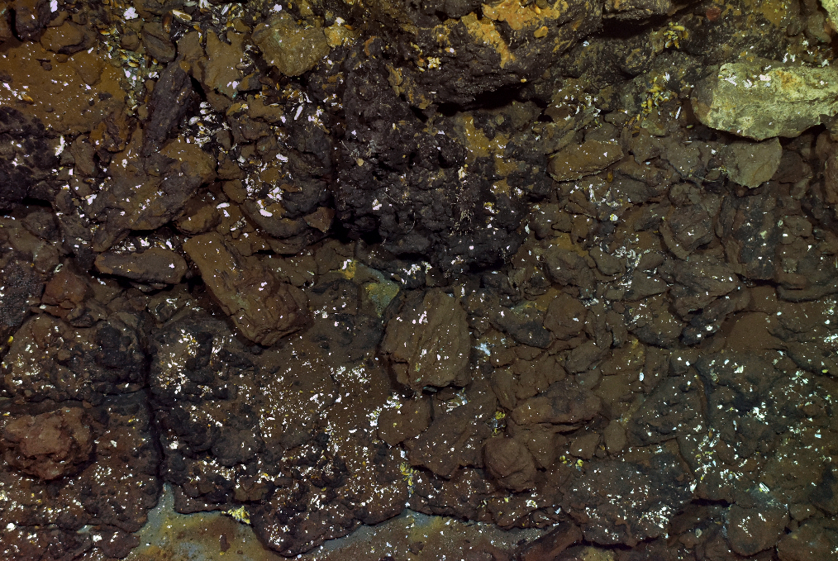
TE/20180818T045716.190198Z.jpg

Environnement > Substrat > Lithology > Hard substrate > Slab
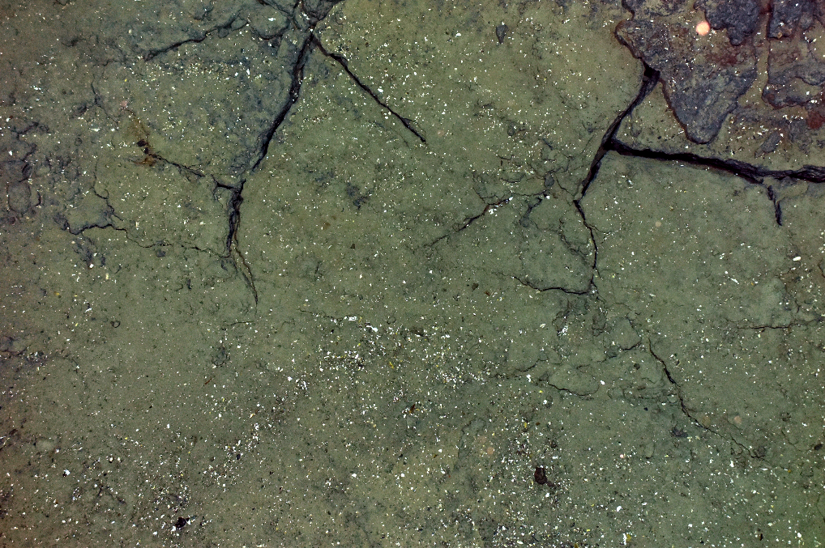
TE/20180818T010813.211538Z.jpg
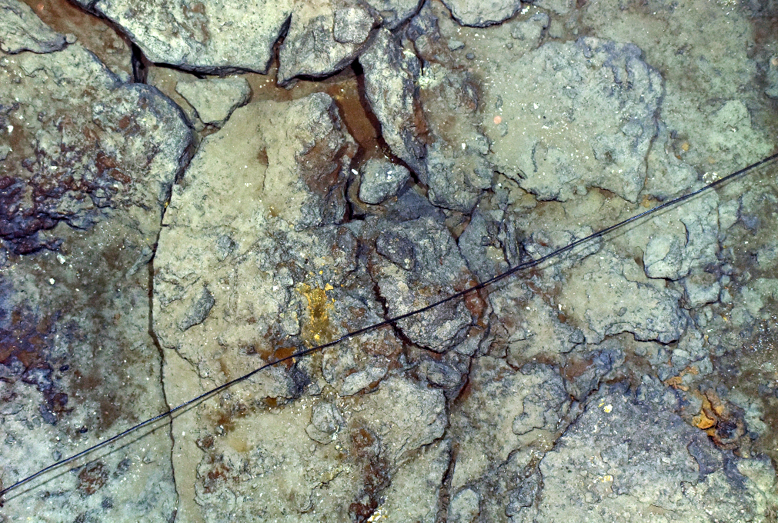
TE/20180818T030928.159310Z.jpg

Geomorphology

Environnement > Substrat > Morphology > Substrate > Plates > Fractured
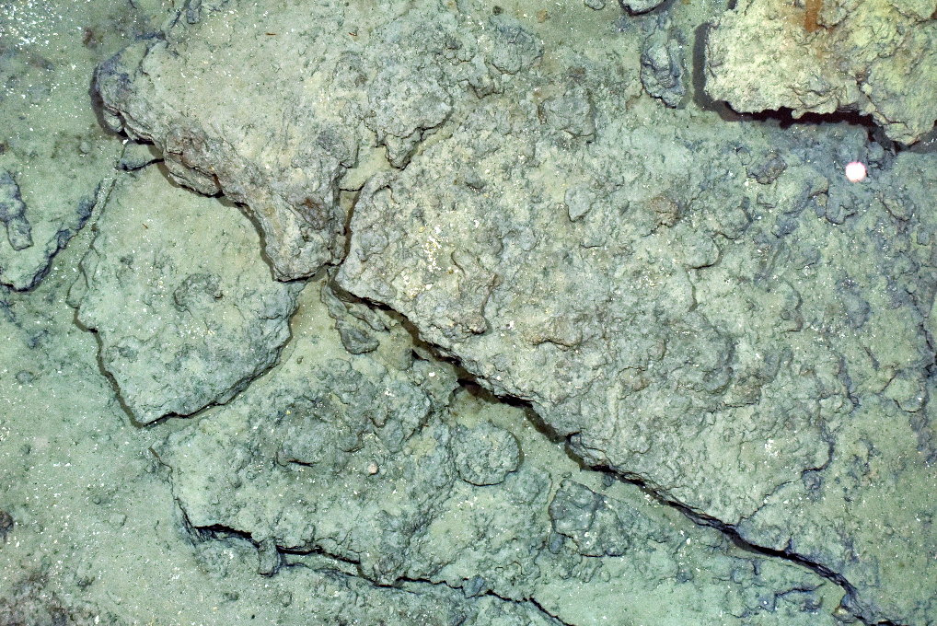
TE/20180818T032918.109539Z.jpg

Environnement > Substrat > Morphology > Substrate > Plates > Sedimented
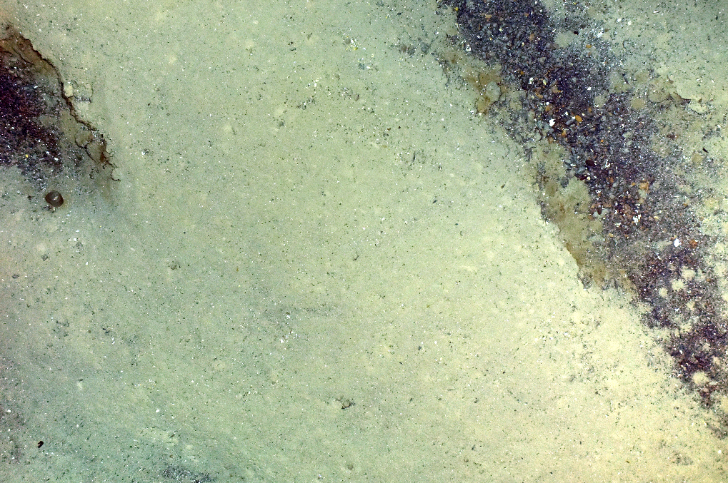
TE/20180818T022118.193819Z.jpg

Environnement > Substrat > Morphology > Substrate > Basaltic > Brecciated / Pillow lava
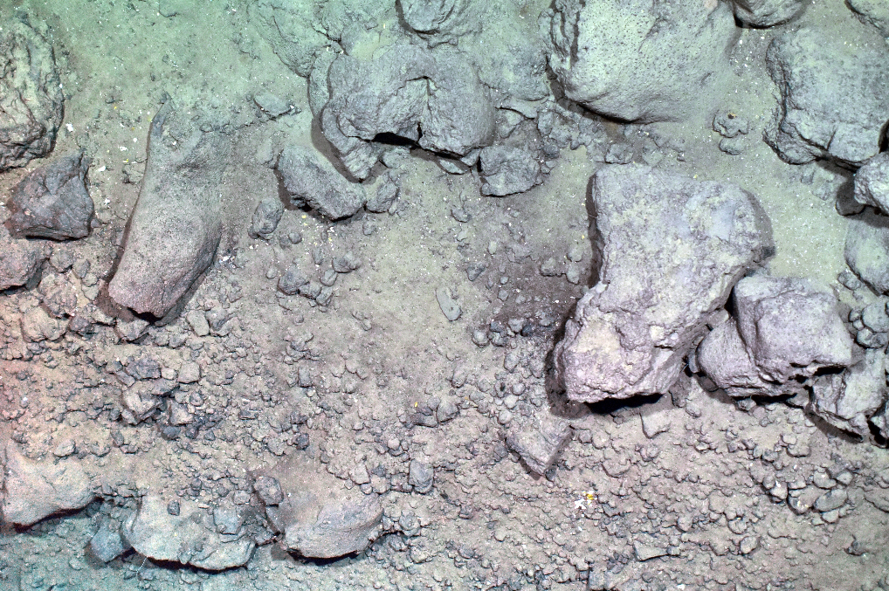
TE/20180824T070124.042981Z.jpg

Environnement > Substrat > Morphology > Substrate > Marbled
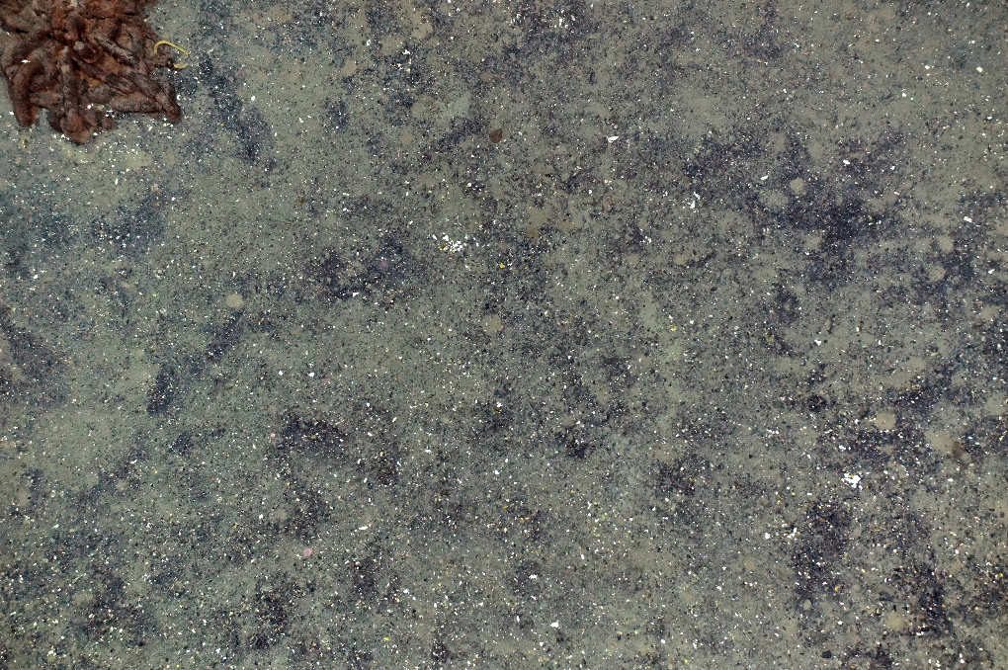
TE/20180818T010933.121165Z.jpg

Environnement > Substrat > Morphology > Scree / rubbles
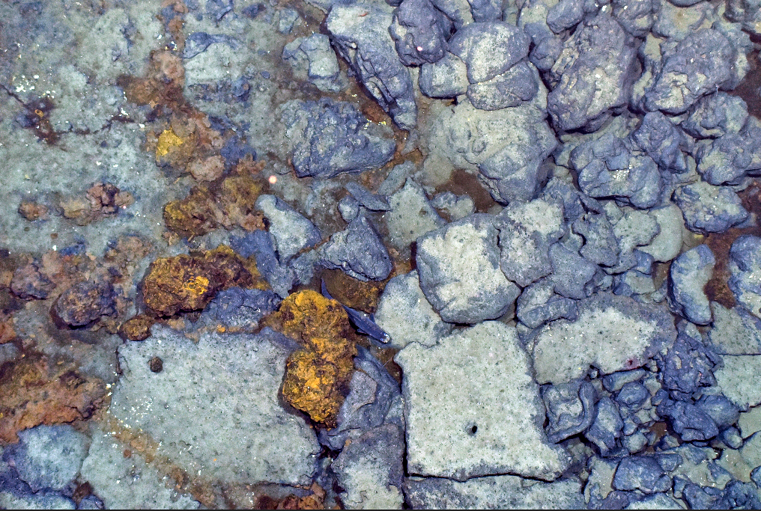
TE/20180818T014053.159813Z.jpg
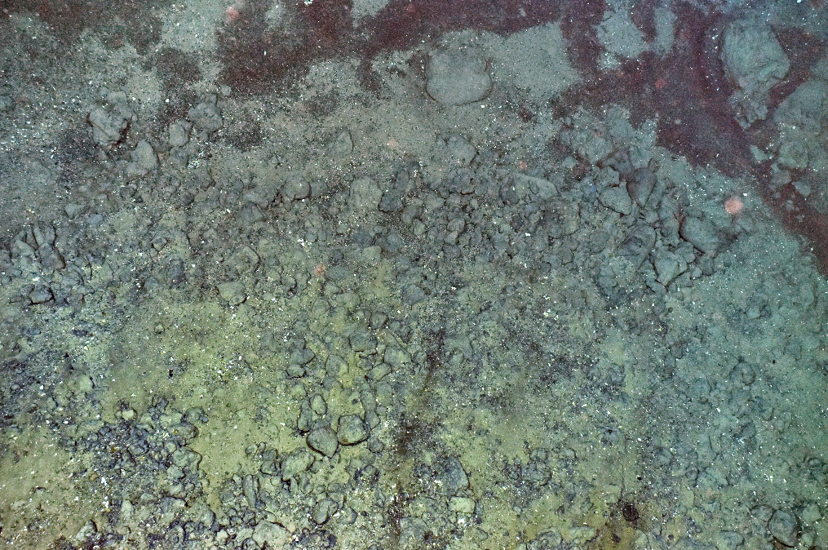
TE/20180819T053509.995887Z.jpg

